

UNIVERSITY OF PETROLEUM AND ENERGY STUDIES
SUB-DATA COMMUNICATION AND NETWORKS
LAB FILE
TOPIC-IMPLEMENTATION OF MESH TOPOLOGY



SUBMITTED BY:- SUBMITTED TO:-
MEHIR SAXENA DR.RAJIB BANERJEE
500123380
BATCH-01
DCN Lab Report
Experiment Title:
Implementation of Mesh Topology in Cisco Packet Tracer

1. Introduction
In modern computer networks, topology refers to the physical or logical arrangement of network devices. One of the most reliable and fault-tolerant topologies is the mesh topology. In a mesh topology, every device is connected to every other device, ensuring high availability and redundancy. This lab explores the implementation of two types of mesh topologies using Cisco Packet Tracer:
- A semi-mesh topology with multiple end devices.
- A full mesh topology among switches with each switch connected to a single end device.

2. Objectives
- To understand and implement mesh topology in a simulated environment.
- To design two mesh topologies with different configurations.
- To analyze the advantages and limitations of mesh topologies.
- To practice using Cisco Packet Tracer for networking simulation and testing.

3. Tools Used
- Software: Cisco Packet Tracer (version 7.x or above)
- Devices:
  - 2960-24TT Switches
  - PC-PT (End Devices)
- Cables:
  - Copper Straight-Through (for PC to Switch)
  - Copper Cross-Over (for Switch to Switch)

Network Topology Overview
Mesh Topology 1: Semi-Mesh with 15 End Devices
- Switches Used: Switch0, Switch1, Switch2, Switch3, Switch4
- End Devices: PC0 to PC14
- Each switch connects to multiple end devices.
- The switches are interconnected to form a partial mesh network for redundancy and improved communication reliability.
- Some switches are connected directly, while others have indirect paths ensuring multiple routes.
Mesh Topology 2: Full Mesh of 10 Switches
- Switches Used: Switch11 to Switch20
- End Devices: PC0(1) to PC9(1)
- Every switch is connected to one end device.
- All 10 switches are fully interconnected, forming a complete mesh topology (each switch has a direct connection to every other switch).
- This results in a total of 45 switch-to-switch connections

Step-by-Step: Mesh 1 (Semi-Mesh with 15 End Devices)
Step 1: Device Placement
- Place 5 switches (Switch0 to Switch4) in the workspace.
- Place 15 PCs (PC0 to PC14) and distribute them across the switches.
Step 2: Connect End Devices to Switches
- Use Copper Straight-Through Cable to connect:
  - PC0–PC2 → Switch0
  - PC3–PC5 → Switch1
  - PC6–PC8 → Switch2
  - PC9–PC11 → Switch3
  - PC12–PC14 → Switch4
Step 3: Interconnect the Switches
- Use Copper Cross-Over Cable to create partial mesh links:
  - Connect Switch0 ↔ Switch1
  - Switch1 ↔ Switch2
  - Switch2 ↔ Switch3
  - Switch3 ↔ Switch4
  - Switch4 ↔ Switch0
  - Also connect additional links (e.g., Switch0 ↔ Switch3) for redundancy.
Step 4: Test Connectivity
- Use the ping command from one PC to another (e.g., PC0 to PC14).
- Ensure all devices communicate through multiple paths.
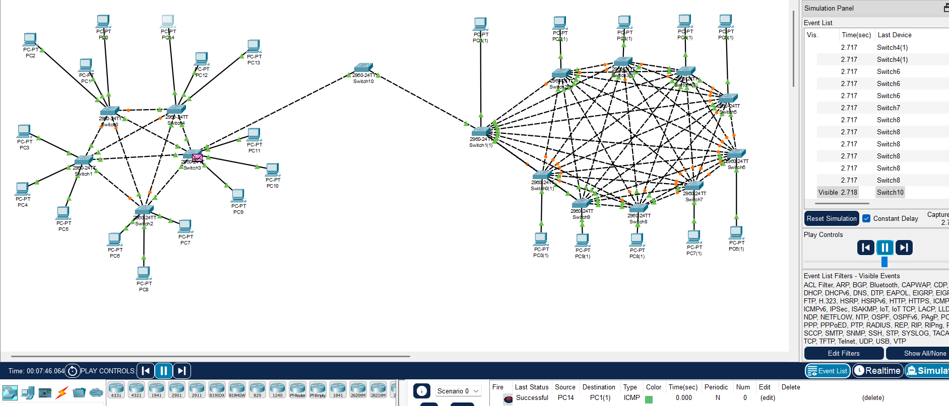
Step-by-Step: Mesh 2 (Full Mesh with 10 Switches)
Step 1: Device Placement
- Place 10 switches (Switch11 to Switch20) in a circular layout.
- Place 10 PCs (PC0(1) to PC9(1)), one for each switch.
Step 2: Connect Each Switch to One End Device
- Use Copper Straight-Through Cable:
Step 3: Interconnect All Switches in Full Mesh
- Use Copper Cross-Over Cable to create direct links between each pair of switches:
  - Switch11 ↔ Switch12, Switch13, ..., Switch15
  - Repeat for each switch until all 45 direct switch-to-switch connections are made.
Step 4: Verify Full Mesh
- All switches should show link lights active.
- Use the ping tool to confirm that each PC can communicate with every other PC in the network.
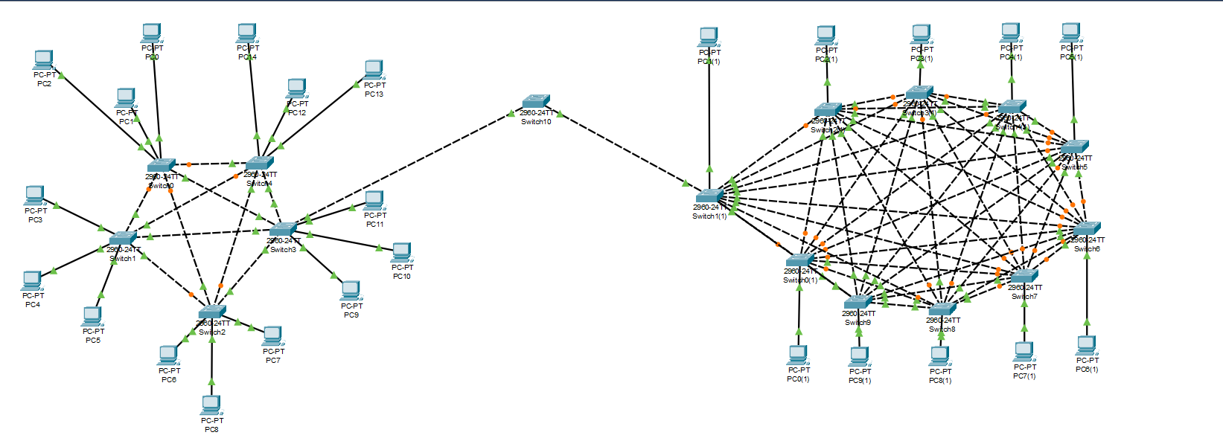
Conclusion
In this lab, we successfully implemented two mesh topologies using Cisco Packet Tracer:
- A semi-mesh topology for scalable communication with moderate redundancy.
- A full mesh topology offering maximum reliability and fault tolerance.
The activity helped us understand the trade-offs between cost, complexity, and network robustness. Full mesh is ideal for mission-critical environments, while partial mesh serves well for moderately critical networks with cost constraints.

